Candidate Number

Please stick the barcode label here.

Marker’s

Use Only
 |  | Marker No.
Question No. |  | Marks
1
2
3
4
5
6
7
8
9
10
11
12
13
Total

ARISTO EDUCATIONAL PRESS

HONG KONG DIPLOMA OF SECONDARY EDUCATION EXAMINATION

ECONOMICS PAPER 2
(Mock Test 39)

Question-Answer Book

Time allowed: 2 hours 30 minutes
This paper must be answered in English

INSTRUCTIONS
- After the announcement of the start of the examination, you should first write your Candidate Number in the space provided on Page 1 and stick barcode labels in the spaces provided on Pages 1, 3, 5, 7, 9, 11, 13, 15, 17, 19, 21, 23 and 25.
- This paper consists of three sections, A, B and C. Answer ALL questions in sections A and B. Attempt any ONE question in section C.
- Write your answers in the space provided in this Question-Answer Book. Do not write in the margins. Answers written in the margins will not be marked.
- Supplementary answer sheets will be supplied on request. Write your candidate number, mark the question number box and stick a barcode label on each sheet, and fasten them with string INSIDE this book.
- No extra time will be given to candidates for sticking on the barcode labels or filling in the question number boxes after the ‘Time is up’ announcement.

Section A (44 marks)

1. The table below shows the input-output relationship of firm A.

Machines (units) | Labour (units) | Average product (units)
3 | 2 | 5
3 | 3 | 4
3 | 4 | 4
3 | 5 | 5
3 | 6 | 6

(a) Based on the above information, explain why labour is a variable factor. (1 mark)

(b) Explain whether the above data illustrates the law of diminishing marginal returns. (2 marks)

2. Suppose the United States imposes an import tariff on motor vehicles produced in Canada.

(a) With the aid of a demand-supply diagram, explain the effect of imposing the above tariff on producer surplus in the market of motor vehicles produced in the United States. (5 marks)

(b) An American driver purchased a car imported from Canada before the imposition of the tariff. The demand for second-hand imported cars has increased after the import tariff took effect. He is considering whether to continue to use the car or resell it. Explain whether the driver’s opportunity cost of continuing to use the car will necessarily remain unchanged when the tariff is in effect.
(3 marks)

Please stick the barcode label here.

3. In 2024, the Hong Kong SAR Government launched the ninth batch of Silver Bonds. The subscription price of Silver Bonds is fixed.

(a) This batch of Silver Bonds recorded an oversubscription. Even when the government increased the issuance amount from $50 billion to $55 billion, there were still some people who could not be allocated the quantity they subscribed for. Illustrate the above phenomenon in a demand-supply diagram. (4 marks)

A Silver Bond is a 3-year bond whose semi-annual interest payments are linked to the average annual inflation rate, subject to a minimum interest rate of 4%. The principal will be repaid at maturity.

(b) Suppose a holder of the above Silver Bond expects the inflation rate in Hong Kong to be 2% in 2025. If Hong Kong’s actual inflation rate in 2025 is 3%, explain whether he will gain or lose during the year. (3 marks)

4. To reduce people’s consumption of high-sugar foods, the government of Country A levies a per-unit sales tax on the manufacturers of high-sugar foods.

Under what condition will the consumers bear a larger tax burden than the producers? Explain your answer with the aid of a demand-supply diagram. (7 marks)

Please stick the barcode label here.
5. The sales revenue of a Hong Kong garment manufacturer was HK$30 million in a certain year. Give TWO reasons to explain why the contribution of the garment manufacturer to Hong Kong’s gross domestic product might be less than HK$30 million. (4 marks)

6. The table below shows the balance sheet of Country A’s banking system. The required reserve ratio of the banking system is 20%. Suppose the public always hold the same amount of cash.

Assets ($ million) | Liabilities ($ million)
Reserves 750  Loans 2,350 | Deposits 3,100

(a) Calculate the excess reserves in the banking system. State TWO possible reasons to explain why the banks keep excess reserves. (3 marks)

(b) The monetary base of Country A is $900 million. Calculate the cash in public circulation and the money supply of Country A. (2 marks)

(c) Suppose the central bank raises the required reserve ratio by 5 percentage points. Calculate the maximum possible change in deposits after deposit creation/contraction. Show your workings. (3 marks)

Please stick the barcode label here.
7. Country A and Country B each have 30 units of resources. The table below shows the amount of resources required to produce garments and rice in the two countries respectively.

 | 1 unit of garments | 1 unit of rice
Country A | 1 | 2
Country B | 2 | 3

(a) Which good would Country A export according to its comparative advantage? Explain. (3 marks)

(b) If the two countries completely specialise their production and trade with each other, find the total output of garments and rice of both countries. (2 marks)

(c) Suppose the transportation cost for each unit of rice traded is 0.15 units of garments and the cost is borne by the exporting country. Find the range of terms of trade (in terms of 1 unit of rice) over which exchange between the two countries is mutually beneficial. (2 marks)

END OF SECTION A

Section B (60 marks)

8. The diagram below shows the distribution of market shares in the air services market of a country.

(a) What is the type of market structure of the above air services market? List TWO features of this type of market structure that distinguish it from all the other types of market structure. (3 marks)

(b) Pilots’ wages in the country typically consist of a basic salary plus wages calculated based on flight hours.

From the viewpoint of the airlines, explain ONE advantage of the above wage payment method over basic salary only. (2 marks)

Firm D went bankrupt due to long-term financial losses and withdrew from the air services market of the country.

(c) Explain how the closure of firm D would affect the price elasticity of demand for air services provided by the other airlines. (2 marks)

(d) Before firm D went bankrupt, Miss Cheung purchased the company’s shares on the stock exchange. Does Miss Cheung need to use her personal assets to repay the outstanding debts of firm D? Explain.
(2 marks)

Please stick the barcode label here.

Price level
Figure 1
SRAS₀
E
LRAS₀
AD₀
Aggregate output
0
9. Figure 1 shows the AS-AD diagram for an economy. Point E is the initial short run equilibrium point of the economy.

(a) Suggest ONE reason to explain why the short run aggregate supply curve is upward sloping. (3 marks)

(b) Explain whether the economy has an inflationary (output) gap or a deflationary (output) gap. (2 marks)

(c) Suppose the government considers raising the standard tax rate of the salaries tax to restore the aggregate output to the full-employment output level. With the aid of Figure 1, explain how the measure can achieve the objective. (6 marks)

(d) An economist suggests that the government adjust the sales tax rate to restore the aggregate output to the full-employment output level. In terms of equity, evaluate this suggestion and the measure in part (c) respectively. (3 marks)

(e) Suggest ONE monetary policy that can also restore the aggregate output to the full-employment output level. Explain how the monetary policy would affect the nominal interest rate in the economy.
(2 marks)

Please stick the barcode label here.

Please stick the barcode label here.
10. Between October and November 2024, several typhoons hit the Philippines. They caused a lot of damage, and many people were injured or died.

(a) A lot of crops were damaged by the typhoons, forcing the farmers to destroy them. Explain whether the value of the destroyed crops would be included in the calculation of the Philippines’ gross domestic product of 2024. (2 marks)

(b) Suppose the prices of most domestic food in the Philippines increased sharply after the typhoon.

(i) Explain whether the above change in price can be regarded as inflation. (2 marks)

(ii) Explain ONE function of price illustrated in this case. (2 marks)

(c) Suppose some Hong Kong citizens purchased locally produced goods and donated them to victims of the disaster in the Philippines. Explain how this would affect Hong Kong’s balance of payments.
(2 marks)

Ms. Chan is a retiree who plans to go to the Philippines to volunteer and help those affected by the disaster. A friend has offered to cover all her monetary expenses during her volunteer work in the Philippines.

(d) ‘Since Ms. Chan is retired and has no income and does not need to pay for any monetary expenses, her volunteer work does not involve any opportunity cost.’ Do you agree with this statement? Explain.
(2 marks)

Please stick the barcode label here.
11. The West Kowloon Cultural District (WKCD) is an important cultural project in Hong Kong. In 2023, 12.6 million local residents and tourists visited the WKCD. Recently, its financial situation has raised public concerns.

Source A: Introduction of the WKCD
There are various cultural facilities in the WKCD, including the Hong Kong Palace Museum and the Xiqu Centre. In addition, there are hotels, offices, and dining and leisure facilities in the district and the surrounding areas.

The WKCD is operated on a financially self-sustaining basis by the West Kowloon Cultural District Authority (WKCD Authority), a non-profit-making statutory body established by the government in 2008. The WKCD Authority needs to maintain the financial sustainability of the WKCD.
(Source: Official website of West Kowloon Cultural District)

Source B: Financial highlights of the West Kowloon Cultural District

(Source: 2023/24 Annual Report of the West Kowloon Cultural District Authority)

Source C: A news article about the West Kowloon Cultural District
A government official stated that the WKCD Authority employs more than 1,400 staff directly. Including indirect employment opportunities (such as tourism-related supporting facilities), the WKCD has created more than 10,000 job opportunities.
(Source: various newspapers)

Source D: Some views on the financial situation of the West Kowloon Cultural District
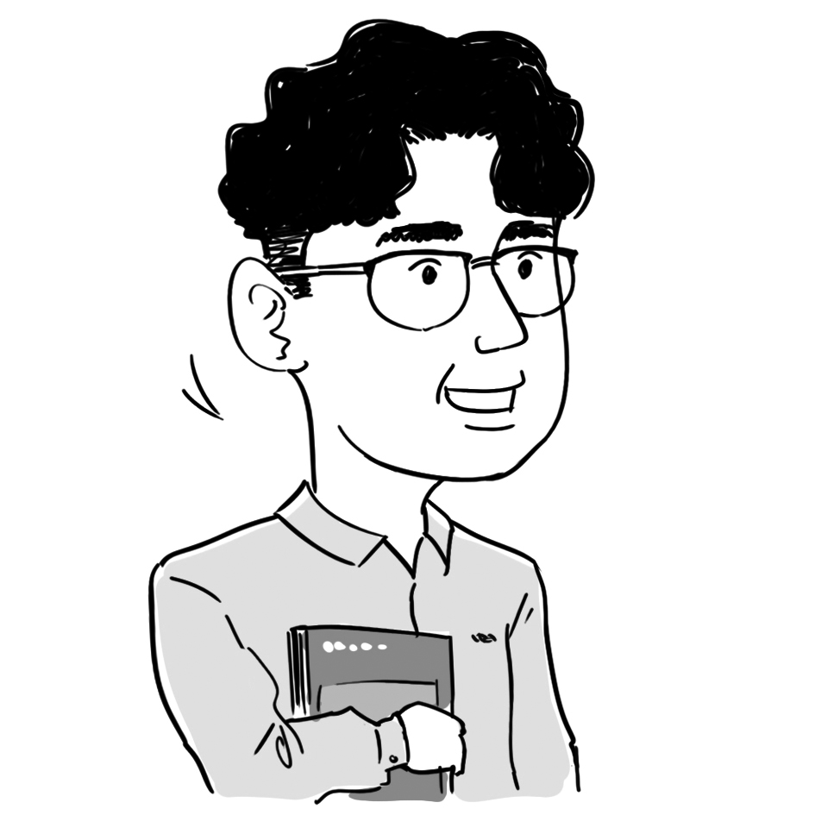  An economics teacher | The WKCD Authority may need to reduce the number of positions held by foreign professionals to reduce costs.
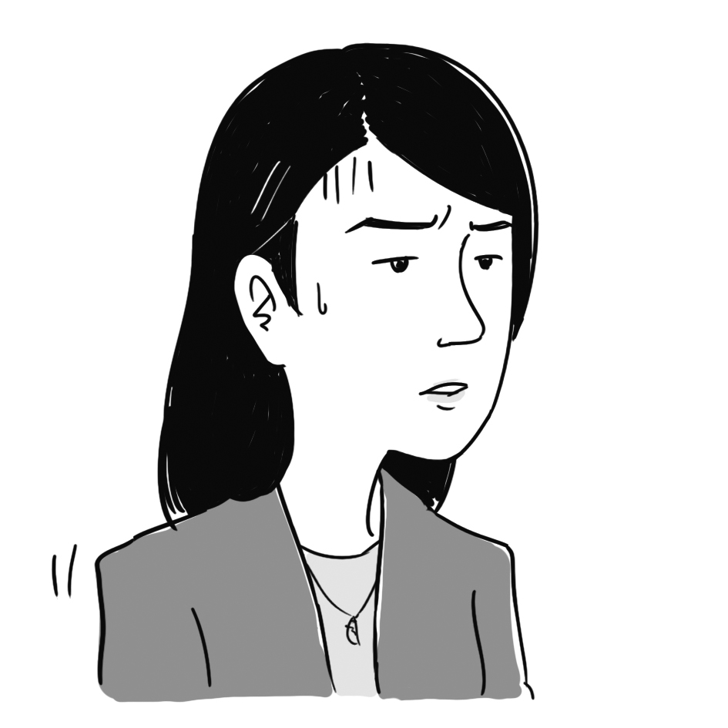  A current affairs commentator | The income of the WKCD Authority includes fundraising, venue hire, ticketing income, sales of museum merchandise, bank interest, etc. However, the current financial structure is unsustainable, and the WKCD Authority may need to find ways to increase income and reduce expenditure to turn a loss into a profit.
  A person in the arts and cultural sector | Running a museum involves different kinds of costs, including the expenses of acquiring collections, marketing expenses, etc. These costs are high and put financial pressure on the WKCD Authority.
  An accountant | If the WKCD Authority sells its residential developments to private property developers, it is expected that the WKCD Authority will receive a huge one-off income. However, the recent downturn in the residential property market may reduce developers’ interest in the developments.

(a) Refer to Source A. State TWO advantages of the WKCD being managed by the WKCD Authority instead of a private enterprise. (2 marks)

(b) Refer to Source B. Describe the change in the profit/loss of the WKCD Authority. (2 marks)

(c) Refer to Source C. Explain how the running of the WKCD may involve externality. (3 marks)

(d) Refer to the view of the economics teacher in Source D. Explain how the suggestion would affect the unemployment rate in Hong Kong. (For simplicity, assume all affected employees will return to their places of origin.) (4 marks)

For part (e), candidates are required to present their answer in essay form. Criteria for marking will include use of sources and economic theories, relevant content, logical presentation and clarity of expression.

(e) Suppose there are two suggestions to help the WKCD Authority achieve financial sustainability.
Suggestion | Objective
Suggestion I: sell residential developments to private property developers, who will then construct the housing | to generate sustainable income from the sales revenue
Suggestion II: reduce the number of employees and lower their wages | to increase profit

With reference to the above sources and your own knowledge in Economics, discuss

- how each of the above two suggestions may achieve its objective;
- some possible factors that may limit the effectiveness of the two suggestions in achieving their corresponding objective; and
- the respective effects of the two suggestions on Hong Kong’s macroeconomic variables (excluding the unemployment rate).
(14 marks)

Please stick the barcode label here.

END OF SECTION B

Please stick the barcode label here.

END OF SECTION B

Unit price
0
Quantity
D₀
MC₀: marginal cost
D₀: demand
Figure 2
MC₀
Section C (16 marks) Answer any ONE question.

12. SmartNet is the only mobile network service provider in Country A and it adopts uniform pricing. Figure 2 shows its demand curve and marginal cost curve.

(a) Indicate the profit-maximising output and price as Q_{M} and P_{M} respectively in Figure 2. (2 marks)

(b) Indicate the deadweight loss caused by SmartNet adopting uniform pricing in Figure 2. (1 mark)

(c) Suppose the cost per user of providing mobile network services decreases due to technological improvement, while SmartNet does not change its output and price. With the aid of Figure 2, explain whether economic efficiency would be affected. (4 marks)

(d) Explain whether the following pricing arrangements of SmartNet constitute price discrimination.

(i) Customers with high data usage pay a lower price per unit of data than customers with low data usage. (3 marks)

(ii) New customers are charged a lower price than existing customers. (3 marks)

(e) SmartNet requires customers to subscribe to its streaming movie service when purchasing mobile network services.

(i) Name the anti-competitive behaviour that SmartNet may engage in. (1 mark)

(ii) If the above case occurred in Hong Kong, which conduct rule of the Competition Ordinance of Hong Kong might SmartNet violated? Explain. (2 marks)

Please stick the barcode label here.

Please stick the barcode label here.
Good Y (units)
Good X (units)
0
20
40
60
80
100
20
40
60
80
100

Figure 3
PPF_{A}
P_{A}
A
B
13. Refer to Figure 3. PPF_{A} is the production possibility frontier of Country A and P_{A} is the production point of the country when there is no trade.

(a) Explain why the production possibility frontier of Country A is concave to the origin. (1 mark)

(b) The slope of the dotted line AB is the world price of good X. With the aid of Figure 3, explain whether Country A has a comparative advantage in producing good X. (Hint: you may add a straight line at P_{A}.) (4 marks)

(c) Suppose Country A engages in international trade.

(i) Indicate the production point (P_{T}) and the consumption possibility frontier (CPF_{A}) of Country A after trade in Figure 3. (3 marks)

(ii) Suppose Country A consumes 30 units of good X after trade. Indicate the import volume of Country A in Figure 3. (1 mark)

(d) After Country A engages in international trade, its Gross National Income per capita rank increases, but its Human Development Index (HDI) rank decreases.

(i) Suggest TWO possible reasons for the decrease in the HDI rank of Country A. (4 marks)

(ii) State ONE developmental dimension that is not measured in the HDI. (1 mark)

(e) Suggest ONE policy that would improve Country A’s HDI ranking. Explain your answer. (2 marks)

Please stick the barcode label here.

END OF PAPER

